**Lab Work: 01.**  


**Course code: CCE-314.**

**Course Title: Computer Network Sessional.**

**Remarks & Signature:**

**Name of the Lab Report:** Building a Local Area Network.

**Submitted To**

**Professor Dr. Md. Samsuzzaman.**

**Professor,**

**Department of Computer and Communication Engineering.**

**Faculty of Computer Science & Engineering.**

**Submitted By**

**HASAN AHAMMAD**

**ID No: 1902073**

**Reg No: 08779**

**Level- 3, Semester- 1**

**Session: 2019-2020**

**Faculty of Computer Science & Engineering.**

**Patuakhali Science & Technology University.**

**Dumki, Patuakhali-8602.**

* **Local Area Network(LAN):** LANs are typically characterized by high data transfer rates, low latency, and private ownership and are often set up using Ethernet or Wi-Fi technology. They are commonly used in homes and businesses to facilitate communication and resource sharing among connected devices.
* **LAN devices:** Various devices are used in a Local Area Network (LAN) to enable communication and resource sharing among connected devices. Here are some common LAN devices:

1. ***Computers/Devices****:* Computers, laptops, smartphones, tablets, and other devices with network capabilities are essential components of a LAN.
2. ***Router:*** Routers are critical devices that manage data traffic between devices within the LAN and provide access to external networks, such as the Internet. They assign IP addresses to devices on the network and facilitate communication between them.
3. ***Switch:*** Switches are used to connect multiple devices within a LAN. Unlike hubs, switches are more intelligent and forward data only to the specific device for which the data is intended, reducing network congestion.
4. ***Hub:*** Hubs are basic networking devices that connect multiple computers in a LAN. Unlike switches, hubs broadcast data to all devices connected to them, which can lead to network congestion.
5. ***Access Point (AP):*** Access points are used to enable Wi-Fi connectivity within a LAN. They allow wireless devices to connect to the network.
6. ***Network Interface Card (NIC):*** NICs are hardware components that enable computers and other devices to connect to the LAN. They can be integrated into the device's motherboard or added as a separate card.
7. ***Modem:*** In scenarios where the LAN needs to connect to the Internet, a modem is used to establish a connection with the Internet Service Provider (ISP).
8. ***Firewall:*** Firewalls are used to enhance the security of a LAN by monitoring and controlling incoming and outgoing network traffic based on predetermined security rules.
9. ***Cables:*** Ethernet cables or fiber-optic cables are used to physically connect devices in a wired LAN.
10. ***Print Servers:*** Print servers manage and coordinate print jobs in a network, allowing multiple users to share a single printer.
11. ***Network Attached Storage (NAS):*** NAS devices provide centralized storage that can be accessed by multiple users in the LAN. They are dedicated file servers for data storage and retrieval.
12. ***Bridge:*** Bridges connect two or more network segments, effectively extending the LAN. They operate at the data link layer of the OSI model.

* **UTP Cable Construction:**

1. **Crossover cable wiring scheme:**

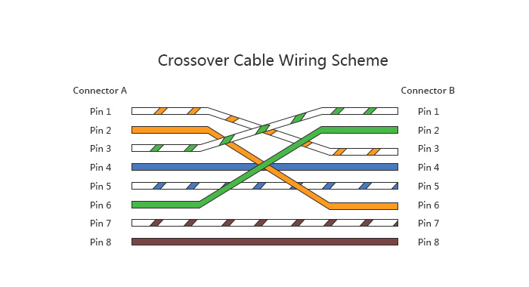

1. **Straight-through cable wiring scheme:**

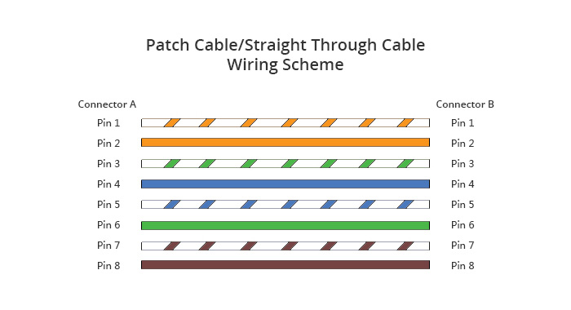

* **Classful IP addressing:**
* **IPv4 address:** An IPv4 address, or Internet Protocol version 4 address, is a numerical label assigned to each device participating in a computer network that uses the Internet Protocol for communication. IPv4 addresses are 32-bit numerical labels, usually represented in decimal format separated by periods. Each of the four segments is called an octet.

The standard IPv4 address format looks like this: **xxx.xxx.xxx.xxx**

Here, each "xxx" represents a decimal number ranging from 0 to 255. For example, an IPv4 address could be something like 192.168.0.1.

* **Rules for Classful IP addressing:** Classful addressing in IPv4 is based on three main address classes: Class A, Class B, and Class C. Each class has specific rules regarding the allocation of IP addresses:
* **Class A Address (1.0.0.0 to 126.0.0.0):**

First octet is the network portion, and the remaining three octets are for host addresses.

Supports up to 128 networks with each having up to 16 million hosts.

* **Class B Address (128.0.0.0 to 191.255.0.0):**

First two octets are the network portion, and the remaining two octets are for host addresses.

Supports up to 16,384 networks with each having up to 65,536 hosts.

* **Class C Address (192.0.0.0 to 223.255.255.0):**

First three octets are the network portion, and the last octet is for host addresses.

Supports up to 2 million networks with each having up to 256 hosts.

* **Class D Address (224.0.0.0 to 239.255.255.255):**

Reserved for multicast groups.

Multicast addresses are used to send a single copy of data to multiple hosts simultaneously.

* **Class E Address (240.0.0.0 to 255.255.255.255):**

Reserved for experimental purposes and should not be used on the public Internet.

Intended for research and development.

* **Classless IP addressing:** often referred to as Classless Inter-Domain Routing (CIDR), is a more flexible way of allocating and specifying IP addresses compared to the traditional classful addressing. CIDR allows for a variable-length subnet mask (VLSM), which means that the division between the network and host portions of an IP address can occur at any bit boundary.
* **Rules for Classless IP addressing:**
* **Prefix Notation:** IP addresses are represented in prefix notation, where the address is followed by a forward slash and the number of bits in the network portion. For example, 192.168.1.0/24 indicates that the first 24 bits are for the network, leaving 8 bits for host addresses.
* **Variable-Length Subnet Mask (VLSM):** CIDR allows for the use of subnet masks of varying lengths. This flexibility is especially beneficial for efficient address allocation and conservation.
* **Aggregation:** CIDR facilitates route aggregation, reducing the size of routing tables by combining multiple contiguous blocks of IP addresses into a single entry. This helps improve the efficiency of routing on the Internet.
* **Efficient Address Allocation:** CIDR allows for more efficient use of IP address space by allocating addresses based on actual network requirements rather than predefined classes.
* **Example:** Instead of specifying a fixed class (A, B, or C), CIDR allows for specifications like 192.168.1.0/24, where the subnet mask length can vary.